 



Database Programming with SQL 10-4: Correlated Subqueries Practice Activities

# Objectives

* Identify when correlated subqueries are needed
* Construct correlated subqueries
* Construct named subqueries using the WITH clause

# Try It / Solve It

1. Explain the main difference between correlated and non-correlated subqueries?

Некоррелированные подзапросы результат внутреннего подзапроса вычисляют первым и повторно используют результат во всем оставшемся запросе

1. Write a query that lists the highest earners for each department. Include the last_name, department_id, and the salary for each employee.

WITH highs AS ( SELECT NVL(department_id,-1), MAX(salary) FROM employees GROUP BY NVL(department_id,-1))

SELECT last_name, department_id, salary

FROM employees

WHERE (NVL(department_id,-1), salary) IN (SELECT * FROM highs );

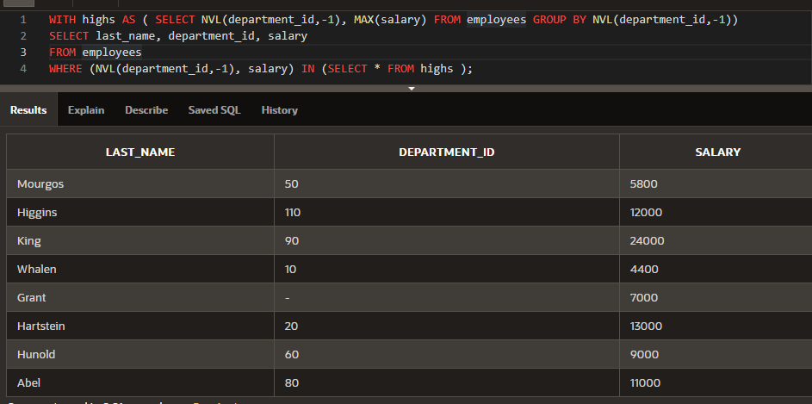

1. Examine the following select statement and finish it so that it will return the last_name, department_id, and salary of employees who have at least one person reporting to them. So we are effectively looking for managers only. In the partially written SELECT statement, the WHERE clause will work as it is. It is simply testing for the existence of a row in the subquery.

SELECT (enter columns here)

FROM (enter table name here) outer WHERE 'x' IN (SELECT 'x'

FROM (enter table name here) inner

WHERE inner(enter column name here) = inner(enter column name here) Finish off the statement by sorting the rows on the department_id column.

SELECT outer.last_name, outer.department_id, outer.salary

FROM employees outer

WHERE outer.employee_id IN (SELECT DISTINCT inner.manager_id

FROM employees inner

WHERE inner.manager_id = outer.employee_id)

ORDER BY outer.department_id;

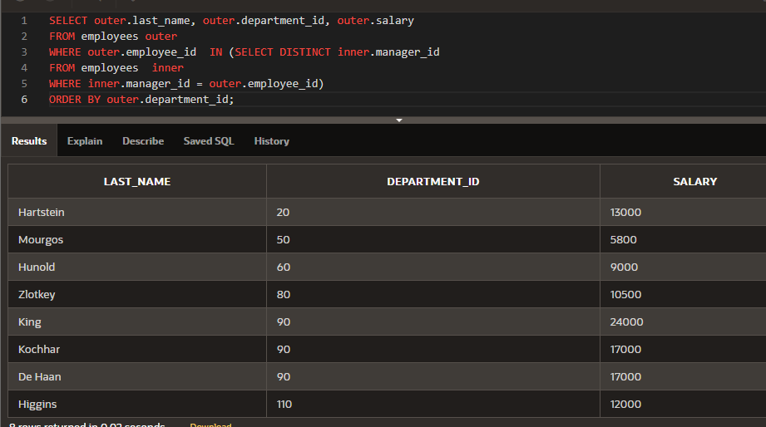

1. Using a WITH clause, write a SELECT statement to list the job_title of those jobs whose maximum salary is more than half the maximum salary of the entire company. Name your subquery MAX_CALC_SAL. Name the columns in the result JOB_TITLE and JOB_TOTAL, and sort the result on JOB_TOTAL in descending order.

Hint: Examine the jobs table. You will need to join JOBS and EMPLOYEES to display the job_title.

WITH max_calc_sal AS (SELECT jobs.job_id , jobs.job_title, MAX(NVL(employees.salary,0)) AS job_actual_max FROM employees RIGHT OUTER JOIN jobs ON employees.job_id = jobs.job_id GROUP BY jobs.job_id,jobs.job_title)

SELECT job_title, job_actual_max AS job_total

FROM max_calc_sal

WHERE job_actual_max > (SELECT MAX(job_actual_max)/2 FROM max_calc_sal)

ORDER BY job_total DESC;

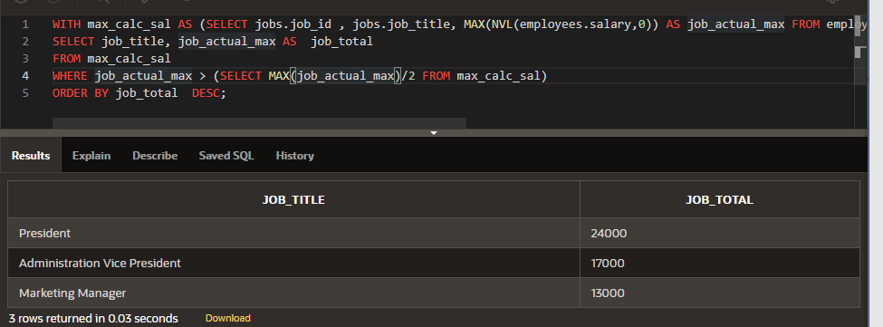

Copyright © 2020, Oracle and/or its affiliates. All rights reserved. Oracle and Java are registered trademarks of Oracle and/or its affiliates. Other names may be trademarks of their respective owners.